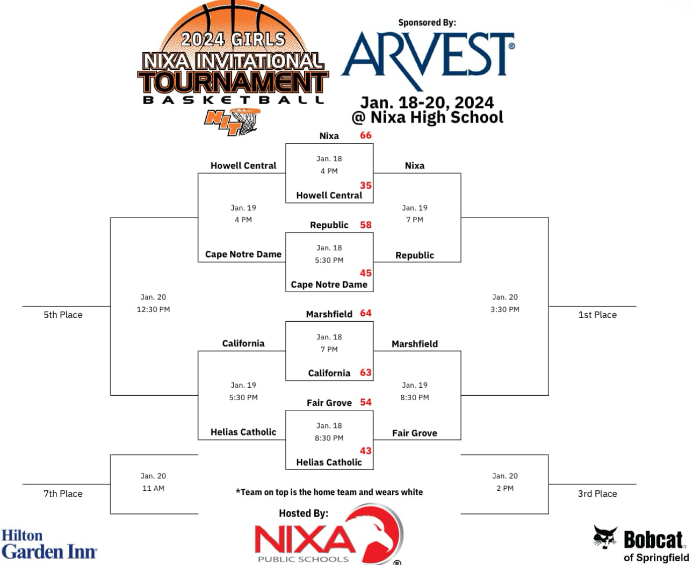

California
Howell
Helias
Fair Grove
Nixa

Cape ND
Marshfield
Republic

